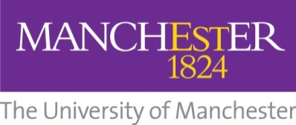

School of Arts, Languages and Cultures
Modern Hebrew level 1 (beginners) or level 2
(MEST10210 or MEST20210) Application Form
This form is to be completed by members of the public only.
Data protection: The University of Manchester requires the information you provide on this form for educational and support purposes. Your personal data will be processed in accordance with the University's registration and current data protection legislation in the UK.
Please email your application form and all relevant attachments to: gemma.mccabe@manchester.ac.uk
The closing date for applications is 23 September 2016. Please contact us or see the website for confirmation of the tuition fee. (Fees covered if invited via Manchester Centre for Jewish Studies.)
Part A: Personal Information
Surname

Given Name(s)

Title

Gender | Male
 | Female
Date of Birth (day/month/year)

Nationality

Country of birth

Country of residence

Country of citizenship

Correspondence address (including country and postcode)

Email address

Telephone number

Part B: English Language Proficiency
Please tick which statement applies to you: | English is my first language.
 | English is not my first language, but I live in an English speaking country and / or I speak English in my work.
 | None of the above (please answer the next question).

If you have answered ‘None of the above’ to the last question, you must fulfil the following English language requirements. Please provide the relevant certificate with your application.
Please note: Some English language test results are only valid for two years. Your English language test report must be valid on the start date of the course.
IELTS overall score of 6.5 with a minimum of 5.5 in each component.

TOEFL iBT overall score of 90 with 17 in listening, 18 in reading, 20 in speaking and 17 in writing.

Cambridge CAE grade B or CPE grade C.

Part C: Previous experience of Hebrew
Which level of Hebrew are you applying for? Please state here: Level:

If you have any previous knowledge of Hebrew, please provide a brief description. If you have had formal training in Hebrew, please give details of previous course(s).

Please note: For the level 1 course, some previous knowledge of Hebrew, such as the alphabet and some ability to read, is acceptable; but the level 1 course is designed for beginners.

Part D: Further information
Do you have a disability or health condition?
If yes, please provide further information:

Part E: Declaration
I confirm that the information above is true, complete and accurate, and no information or other material requested has been omitted.

If applicable, please confirm here if you have provided a copy of your English language level certificate with your application form.

Please email your application form and all relevant attachments to: gemma.mccabe@manchester.ac.uk
The closing date for applications is 23 September 2016

