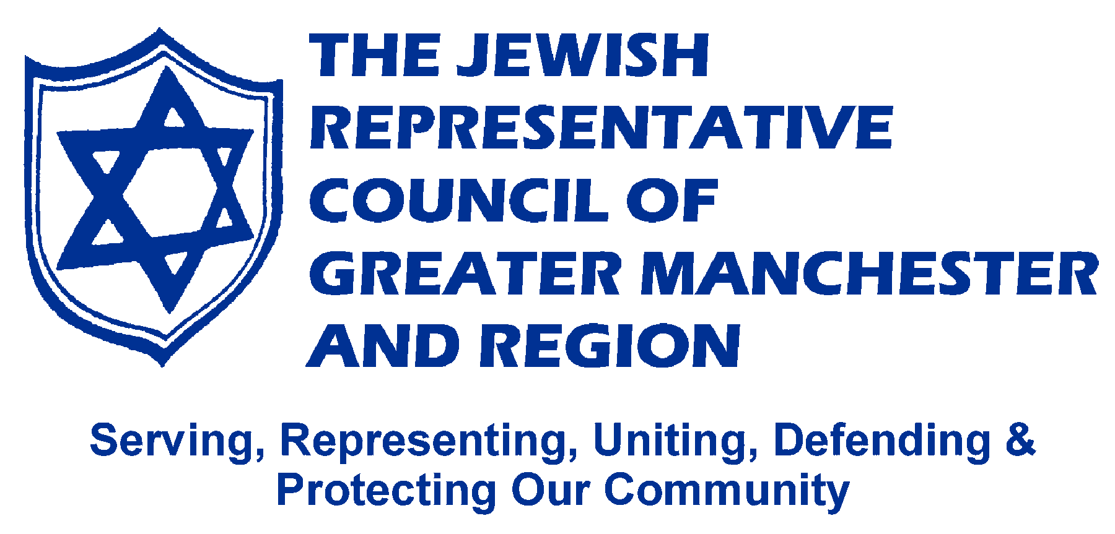

ANNUAL REPORT 2016

Mission of the Council
To serve, represent, unite, defend and protect Jewish interests and provide opportunity for collaboration and co-ordinated action in Greater Manchester and Region.

Aims of the Council:
- Provide infrastructure support to affiliated organisations, building their capacity to deliver services and activities;
- Respond to need across the Jewish community, contributing to and, where appropriate, facilitating strategic planning in education, welfare, culture and health;
- Effectively represent the interests of the Jewish community to public sector organisations and positively influence their policies, strategies and plans to give the best outcomes for the community;
- Engage with businesses to improve prospects for Jewish young people and the prosperity of the community;
- Improve perceptions of Manchester's Jewish community amongst its residents and the wider Jewish and mainstream community.

Chair of Executive’s Report
It has been a quite remarkable year for the Jewish Representative Council with the amount of work being undertaken exceeding most everyone’s expectations.
The new Working Group structure has given us an impetus and freedom to bring new people into our structures and be more proactive in our work. A majority of Groups have seen excellent progress and we can develop work in the areas that have not advanced as fast.
The diverse work of the Jewish Representative Council is viewed with some amazement by those we engage with outside our community. From education to health issues, international to local concerns, the need of the young to those of the elderly, religious to secular residents, the Council looks to respond to anything and everything that is brought to our attention. The amazement comes when our friends are informed that the work is carried out wholly by volunteers, with some administrative and finance support.
Our volunteers undertake work in a myriad of roles within the Council on behalf of the community. During 2016, over 50 individuals gave their time to help us in our work. Many represented us to Local Authorities or NHS Trusts; on police bodies, SACREs and interfaith groups; to the Board of Deputies and partner organisations and at civic occasions. Other helped run events such as Yom HaShoah, the Jewish Community Awards, our Annual Community Challenge Quiz, the Big Neighbourhood Bash, Collabor8 and election hustings. Yet more help update our website, produce RepPresents, run training sessions, collate our Year Book and so much more.
A recognition of this work came in the New Year’s Honours with the award of the British Empire Medal to our President, Sharon Bannister. Through her commitment, public spirit and selflessness, Sharon has earned the respect of her peers. She is a role model to our community and we know that she will continue to serve us with great distinction.
To all who have volunteered and supported us, our thanks. To the wider community, we invite you to get involved in our work, attend our events and support our continued developments.
Working Groups’ Progress in 2016
Education
- St Annes – we visited Rabbi Ephraim Guttentag and two of his committee in August and were warmly welcomed. We offered the help of the JRC to develop a programme of social and cultural activities. This acted as a catalyst for the St Anne’s Community to launch a successful programme after Sukkot.
- Salford HMD 2017 - There was a question about which Salford committee would manage the event. We attended meetings and helped put the Salford HMD programme back on track.
- Sherman Community Lecture – In partnership with the ZCC and the Centre for Jewish Studies at Manchester University, we held a successful lecture in May at Manchester Jewish Museum with Dr Yulia Egorova on Jewish-Muslim relations in the UK. We are now planning the 2017 lecture with Professor Abigail Green of Oxford University. It will take place on May 25th, 5.30pm at Manchester Jewish Museum. The title is “A Century of Jewish liberalism 1848 – 1948”.
- We ensure representation on the SACREs across the region and bring together the Jewish SACRE representatives to discuss common issues within our group.
- We have begun to develop a strategy that will see The EWG act as a facilitator, bringing groups together to become more than the sum of their parts, enhancing what education is available to Greater Manchester Jewry.

Publicity
Achievements:
- Two editions of RepPresents were produced during the year showcasing the diverse work of the Council and promoting upcoming events, including many being run by our affiliates and partners.
- The Social Media & Advocacy Training in November was a great success with 25 representatives attending from a range of affiliated organisations.
- Several Press Releases were written to the media following our events
- The New JRC Promotional Leaflet was produced, the first for many years. It outlines our aims, achievements, activities and how people can support our work. It has been distributed at many events over the year.
- There has been a significant increase in the number of people accessing the JRC's Twitter and Facebook pages.
- Our website continues to be the first port of call for those wishing to know about what is happening our community with the community directory, communal diary, news and twitter feed.
Our future plans include:
- RepPresents continuing to be the voice of the Council and to include more content on our affiliates and community developments.
- A new website in the New Year as part of an integrated system with blogs, calendar, database, event management, membership management and more.

Youth & Community
Achievements:
- Mapping exercise of youth activity has substantial data ready to be put into usable form.
- Several positive meetings with young people including Head Boys & Girls of King David High and Yavneh Schools.
- Jewish Arts Festival Committee formed with plans to have several events in summer 2017.
- Organised the sixth Jewish Community Awards in partnership with the Jewish Telegraph and Jewish Volunteering Network. Over 300 people attended the event, which was an example of the community at its finest, showcasing people’s kindness, generosity and commitment.
- Organised, in partnership with Prestwich Hebrew Congregation, a community debate on the EU Referendum. Over 200 people took part in an excellent and informative evening with senior figures from both the Leave and Remain campaigns plus a side panel of undecided members from the local Jewish community.
- Helped organise The Big Neighbourhood Bash in partnership with 5 other organisations on December 18th at Tesco Cheetham Hill. Around 1,000 people attended throughout the day and it was a superb event contributing to community cohesion.
- Organised Xmas Day Transport with 27 volunteers helping transport people to events in North and South Manchester.
Future plans for:
- Meeting of new Jewish Youth Forum.
- Implementation of Jewish Youth Survey.
- Development of Awards for All bid to include:
- Support for young people around bullying, mental health and other issues.
- Sharing information as to Jewish youth activities available in Manchester.
- Interfaith work with opportunities for young people.
- Youth page in future editions of RepPresents.

Public Relations
Achievements:
- Production of a list of ‘go to’ people, a database of experts in the community who can be called on to represent the community in their specialist area. We are still waiting on feedback from organisations to complete this task.
- Representation to Councils, NHS, Police and other statutory bodies. We have continued to have many representatives on various bodies and, in December, held an exceptionally successful Civic Reception in partnership with the JLC for many of the region’s MPs, Councillors, Mayors and others.
- Interfaith work where our members have been key contributors to Salford Interfaith Network, Faith Network 4 Manchester, The Muslim Jewish Forum, Hindu Jewish Association and to the wider Greater Manchester Interfaith Network. This has included being a partner in successful initiatives such as the Big Neighbourhood Bash and Collabor8.
- Several Press Releases responding to current issues.
- The Yom Hashoah Commemoration in partnership with the second generation society. Thanks to increased involvement from them, this has gone from strength to strength in recent years.

For the future we are looking to:
- Create a network for members of the community involved in representation work to meet and discuss key issues. In addition we will look at ways to assist people looking to get more involved.
- More regularly produce press releases when matters arise that require an official response or when we have been asked to comment by the press.
- Run a Councillors’ Seminar in the spring in partnership with the JLC and Board of Deputies.

Fundraising
Achievements:
- Annual Quiz – A very successful event was held in November at the Hilton Suite with 19 teams from across our community.
- Raffle – A new initiative for which we have sold tickets within the community and at community events. To be drawn in February 2017.
- Variety show – Event being organised featuring local Jewish talent at Bury Shul in February to celebrate the draw of the Big Annual Raffle.
- Year Book – This was dedicated to the memory of Dr Sidney Baigel z’l who worked tirelessly for so many years in the production of this publication. It continues to be a key resource for community information as well as a major fundraiser for the Council.
- Event check doc – A checklist has been drafted for discussion to be used at events to cover all actions etc. that need to be completed when planning events.

Future plans for:
- Sub group to plan the year book 2017.
- Exploring different venues for the quiz, possibly rotating yearly between South and North Manchester.
- Review and recording positives, negatives, catering requirements and so forth following events.
- The development of an effective database to support Fundraising activities.
- Discussions on further options for events to gain support from the wider community.

Antisemitism & Human Rights
Achievements:
- Contributed to the Chakrabati Labour Antisemitism Enquiry and consultation.
- Circulated comments widely on the Home Office select committee enquiry into antisemitism within the Labour Party.
- In partnership with the ZCC, ran a series of four lectures entitled ‘Antisemitism, Anti-Zionism and the Law’ featuring Dr Ronnie Fraser, David Collier, Rebecca Long-Bailey MP and Lesley Klaff.
- Explored feasibility of hosting Joint sessions with other organisations/ communities around the Antisemitism issue
- Highlighted issues of human rights abuses in social media
- Encouraged Advocacy against Anti-Semitism online through training in the use of online media tools
- Monitored overall changes in local and national statistics concerning Antisemitism

Future plans for:
- Hosting and facilitating encounters and events to counter Antisemitism with a specific event being explored for the new year.
- Increased social media presence.
- Increased representation to political parties.

Other Work
Outside of our Working Group structure, we convene the Manchester Jewish Care Forum, bringing those organisations involved in social and health care in the community together twice a year to discuss issues of common interest. In August we were joined by Irfan Syed, BME Engagement Officer for NHS Salford Clinical Commissioning Group. We have also had ongoing input to the Faith in Mental Health initiative, including helping plan the successful conference in December with over 130 delegates.
We continue to respond to numerous queries on diverse issues related to the community, from requests to undertake research; invitations for representation at forums, meetings and networks; how to provide kosher food; requests to volunteer and much more. Our thanks go to our Administrator, Laurie Burnley-Myers, who joined us in May and is our first contact for these queries as well as supporting our increasing workload.
Finally, my thanks to my fellow Officers and Executive Members who have contributed to such a remarkable year.

