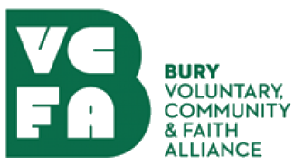

Volunteering Position Statement in relation to Coronavirus
March 2020

Bury Communities are all working together to support our most vulnerable residents during the Coronavirus global pandemic.

Volunteers will be critical to meeting the national direction for people to Stay at Home; Protect Lives & Save the NHS, but efforts must be co-ordinated and delivered in a way which protects the health and safety of volunteers themselves.

Joint guidance from the Council and VCFA to all volunteers at this time is as follows:

- The Council has set up Community Hubs in 5 neigbourhood areas. These Hubs will maintain records of the most vulnerable residents and co-ordinate volunteers accordingly. All volunteers are asked to connect with their local Hub, the contact details may be found here

- Volunteers supporting vulnerable people should normally have DBS clearance. The allocation of work to volunteers without such clearance will be allocated on a risk assessed basis by the Community Hubs

- Reasonable expenses for volunteers delivering work on behalf of Community Hubs will be reimbursed

- Volunteering should be delivered remotely (over the phone or online) as far as possible

- Providing help and care in person for a vulnerable person is an exception to the government requirement to stay at home but on the basis that:

  - it should involve no more than two people from different households or a larger group from a single household

  - only if there are no other options and as infrequently as possible

  - social distancing applies when supporting vulnerable people, ensuring you are 2 metres apart from anyone outside of your household.

- Formal volunteering opportunities in the Borough are channelled through the Bury Voluntary Community and Faith Alliance (VCFA). If you’d like to volunteer in the Borough this is the first point of contact https://www.buryvcfa.org.uk/volunteering/

- Volunteers affiliated to VCFA groups or community groups engaged through the hubs are able to collect a letter from the Council which confirms their role, if required – these are available upon request by calling 0161 253 5353.

Together we can make a real difference, to protect lives in the Borough, to support people through these physically, emotionally and financially challenging times.

Thank you.

